Table of Contents

生成模型 1

生成模型vs判别模型 1

**分布变换：均匀分布 -> 其他分布** 4

如何学习数据分布？ 6

生成图像 10

Stable Diffusion 10

**Conditioning: T2I-Adapter, ControlNet** 14

ControlNet 15

Text Generation Models 16

Prompt Engineering 17

AI Agent 设计模式 21

AI Agent Frameworks 22

OpenAI 22

GAN 25

Image Caption(看图说话) 25

VQA (Visual Question Answering) 25

# 生成模型

## 生成模型vs判别模型

生成模型是所有变量的全概率模型，学习给定观测变量 X 和目标变量 Y 的**联合概率分布 $p(X, Y)$**

判别模型是学习给定观测变量X时，目标变量Y的**条件概率分布 $p(Y|X)$**

生成模型不仅可以预测给定观测 X 的目标 Y，还能够"生成"能生成新的观测实例和目标实例。而判别模型只能根据观测变量得到目标变量的采样。

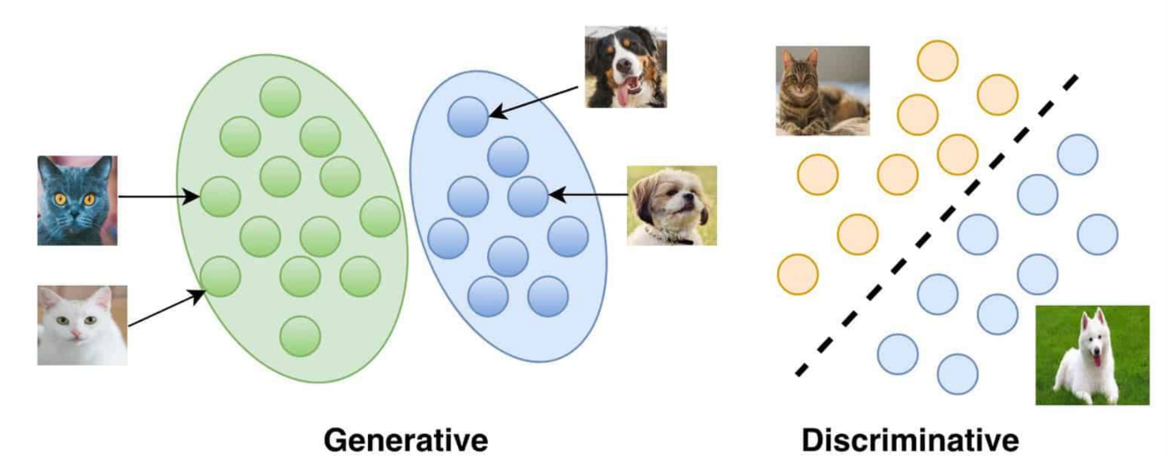

|  |  |  |
| --- | --- | --- |
| 模型目标不同 | * 学习观测数据 X 和目标变量 Y 的联合概率分布 P (X,Y) * Generative models possess discriminative properties. | * 学习给定观测数据 X 时，目标变量 Y 的条件概率分布 P (Y|X) * Discriminative models don’t possess generative properties |
| 建模方式不同 | Maximizes the joint probability: p(y,X) | Maximizes the conditional probability: |
| 用于分类器 | * Typically, they are NOT used to solve classification tasks * For classification, estimates to find using Bayes’ rule | * Specifically meant for classification tasks * Directly estimates |
| 应用场景不同 | 由于能够学习数据的分布，因此可用于生成新的类似于训练数据的样本 (e.g., txt, img, video) | * Cannot generate new data * 更适用于对给定输入进行分类或预测的任务 |
| Models | * 传统生成式模型：Naïve Bayes, Gaussian Mixture Model, LDA, Hidden Markov Model, * 深度生成式模型：VAE, GAN, DM | Logistic Regression, Random Forests, SVMs, NN, DT |

生成式模型应用场景：

生成式模型可以生成与训练数据具有相似特征的新数据实例

* 内容生成。图像、文本、音频、还能图像到图像的转换、文本摘要生成和音乐生成等任务。
* 异常检测。生成式模型可以学习正常数据的分布，并识别不符合该分布的异常值。
* 强化学习。在强化学习中，生成式模型可以学习生成行动序列来实现特定目标，从而在决策制定和规划等领域发挥作用。
* 加速药物发现。在医疗保健和生命科学领域，生成式模型可用于创建具有特定性质的新蛋白质序列，从而加速抗体、酶、疫苗和基因疗法的设计。它们还可用于设计合成基因序列，应用于合成生物学和代谢工程。
* 生成合成数据。生成式模型可用于创建合成患者和医疗保健数据，这对于训练 AI 模型、模拟临床试验或研究罕见疾病等具有重要价值。
* 优化业务流程。在汽车和制造业中，生成式 AI 可用于评估和优化营销、广告、财务和物流等领域的成本降低方案，从而优化业务流程。
* 提高员工生产力。生成式 AI 可以通过生成多种原型来支持创意任务，或协助代码生成、销售脚本、电子邮件内容和博客文章等写作任务，从而提高员工的工作效率。
* 金融服务。投资公司可以利用生成式 AI 以低成本为客户提供个性化的金融建议。

**生成模型用于分类**

对于**分类问题**，不论生成式模型还是判别式模型，分类器判断依据都是条件概率 $p(C|F_{1}, …, F_{n})$

* 判别式模型是对条件概率建模，根据训练数据得到分类函数和分界面，然后直接计算条件概率，无法反映训练数据本身的特性，能力有限，其只能告诉我们分类的类别。
* 生成式模型一般会对每一个类建立一个模型，比如说类别标签有｛男性，女性｝，首先根据男性的特征学习出一个男性的模型，再根据女性的特征学习出女性的模型，之后分别计算新样本 跟两个类别的联合概率 $p(C,F_{1}, …, F_{n})$。然后根据Bayes公式分别计算 $p\left(C | F_{1}, …, F_{n}\right)=\frac{p(C,F_{1}, …, F_{n})}{p(F_{1}, …, F_{n})}$，选择两类中最大后验概率。

Bayes分类器是生成模型

**联合分布模型 $p(C,F_{1}, …, F_{n})$**

$$p\left(C,F_{1}, …, F_{n}\right)∝p\left(C\right)p\left(F_{1}, …, F_{n} | C\right)$$

$∝p\left(C\right)p\left(F_{1} | C\right)p\left(F_{2}, …, F_{n} | C,F_{1}\right)$

$∝p\left(C\right)p\left(F_{1} | C\right)p\left(F_{2} | C,F_{1}\right)p\left(F_{3}, …, F_{n} | C,F_{1},F_{2}\right)$

$∝p\left(C\right)p\left(F_{1} | C\right)p\left(F_{2} | C,F_{1}\right)p\left(F_{3} | C,F_{1},F_{2}\right)…p\left(F_{n} | C,F_{1},F_{2},…,F_{n-1}\right)$

朴素Bayes假设特征条件独立：即每个特征 $F_{i}$ 对于其他特征 $F_{j}$ 在給定类別 $C$ 下是条件独立的。这就意味着 $p\left(F_{i} | C,F_{j}\right)=p\left(F_{i} | C\right)$

$$p\left(C,F_{1}, …, F_{n}\right)∝p\left(C\right)p\left(F_{1}, …, F_{n} | C\right)$$

$$∝p\left(C\right)p\left(F_{1} | C\right)p\left(F_{2} | C\right)p\left(F_{3} | C\right)…p\left(F_{n} | C\right)$$

概率模型分类器是一个条件概率模型:

$p(C|F_{1}, …, F_{n})$ 其中类别变量 $C$，条件依赖于特征变量 $F_{1}, …, F_{n}$

根据Bayes定理： $p\left(C | F_{1}, …, F_{n}\right)=\frac{p\left(C\right)p\left(F_{1}, …, F_{n} | C\right)}{p(F_{1}, …, F_{n})}$

即 $posterior(先验概率)=\frac{prior \left(先验概率\right)× likelihood}{evidence}$

因为分母不依赖于 $C$ 而且特征 $F_{1}, …, F_{n}$ 是给定的，于是分母可以认为是一个常数。这样分子就等价于**联合分布模型 $p(C,F_{1}, …, F_{n})$**

从概率模型中，基于MAP(最大后验概率决策准则)，构造分类器:

$$classify\left(f_{1}, …f_{n}\right)=argmax p(C=c)\prod_{i=1}^{n}{p\left(F_{i}=f_{i}\right)|C=c)}$$

例：性别分类

问题描述:通过一些测量的特征，包括身高、体重、脚的尺寸，判定一个人是男性还是女性

|  |  |  |  |  |  |  |  |
| --- | --- | --- | --- | --- | --- | --- | --- |
| 性别 | 身高(英尺) | 体重(磅) | 脚的尺寸(英寸) | 性别 | 身高(英尺) | 体重(磅) | 脚的尺寸(英寸) |
| 男 | 6 | 180 | 12 | 女 | 5 | 100 | 6 |
| 男 | 5.92 | 190 | 11 | 女 | 5.5 | 150 | 8 |
| 男 | 5.58 | 170 | 12 | 女 | 5.42 | 130 | 7 |
| 男 | 5.92 | 165 | 10 | 女 | 5.75 | 150 | 9 |

求身高6英尺，体重130磅，脚8英寸的性别？

假设训练集样本的特征满足高斯分布，得到下表：

|  |  |  |  |  |  |  |
| --- | --- | --- | --- | --- | --- | --- |
| 性别 | 均值(身高) | 方差(身高) | 均值(体重) | 方差(体重) | 均值(脚尺寸) | 方差(脚尺寸) |
| 男性 | 5.855 | 3.5033e-02 | 176.25 | 1.2292e+02 | 11.25 | 9.1667e-01 |
| 女性 | 5.4175 | 9.7225e-02 | 132.5 | 5.5833e+02 | 7.5 | 1.6667e+00 |

假设两种类别等概率：P(male)= P(female) = 0.5

男性后验概率 $posterior\left(male\right)=\frac{P\left(male\right)p\left(height | male\right)p\left(weight | male\right)p(foot|male)}{evidence}$

$$p\left(height | male\right)=\frac{1}{\sqrt{2πσ^{2}}}\exp\left(\frac{-{\left(6-μ\right)}^{2}}{2σ^{2}}\right)=1.5789$$

注意：这里的值大于1，这里是概率密度而不是概率，因为身高是一个连续的变量.

同理求得 $p\left(weight | male\right)$， $p(foot|male)$

女性后验概率 $posterior\left(male\right)$ 大于男性后验概率 $posterior\left(male\right)$，预计这个样本是女性。

## **分布变换：均匀分布 -> 其他分布**

**均匀分布随机数发生器**，常见的有线性同余法Linear congruential generator（LCG）：

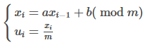 glibc 中采用的默认参数：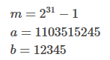

def lcg(seed=0):

x= seed

a=1103515245

b=12345

m=2**31-1

while True:

x = (a*x + b) % m

x = x/m

yield x

**逆变换采样：**

随机变量 $X$ 分布 $f(x)$, 其CDF(累积分布函数): $F_{X}=P\left(X≤x\right)$ 是个单调函数。

CDF反函数: $F_{X}^{-1}\left(u\right)=\inf\left\{x:F_{X}\left(x\right)=u\right\}, 0<u<1$

若随机变量 $U=F_{X}^{-1}\left(X\right)$ 为均匀分布，则 $F_{X}^{-1}\left(U\right)$ 与随机变量 $X$ 同分布

证明： $P\left( F_{X}^{-1}(U)≤x\right)=P\left(inf{\{t: F}_{X}\left(t\right)=U\}≤x\right)=P\left(U≤F_{X}\left(x\right)\right)=F_{U}{(F}_{X}(x))=F_{X}(x)$

指定分布采样

均匀分布采样方法作为基础方法，为其他更复杂的分布的采样提供支持

指数分布：

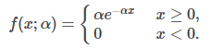

让指数分布的CDF服从均匀分布，那么其逆函数服从指数分布

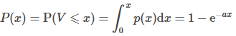

求逆函数：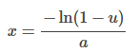

因此从均匀分布 $U[0,1]$ 中采样一系列的 $u_{i}$，代入上式获得 $x_{i}$ 便服从指数分布

指定分布 $f(x)$ CDF {x, y=[0, 1]}

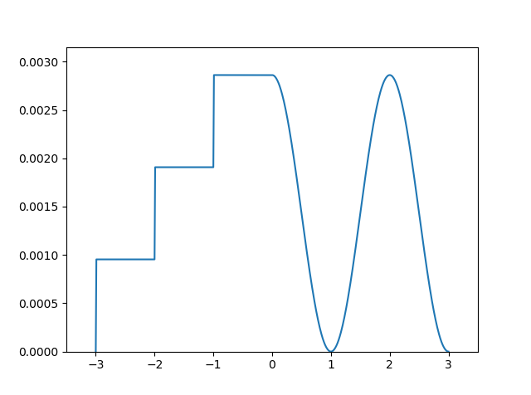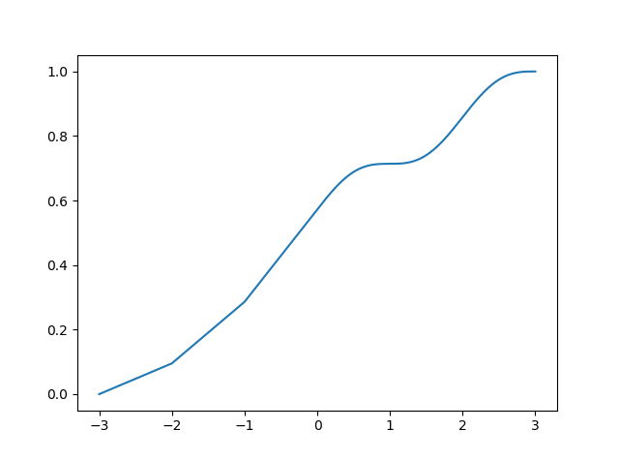

均匀分布，对CDF y轴，进行插值

得{x=指定分布, y=均匀分布} x=指定分布

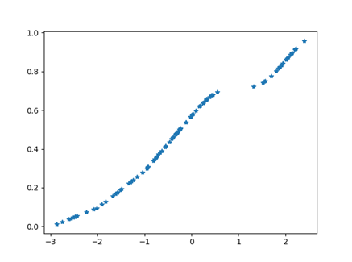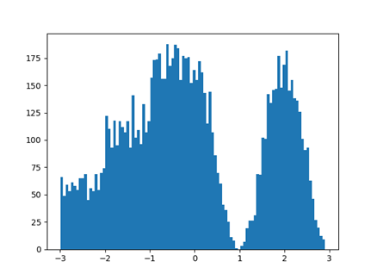

高斯分布采样

利用中心极限定理生成正态分布

设 $X_{1},…X_{n}$ 为独立同分布的随机变量序列，均值为 $μ$，方差为 $σ^{2}$，

则 $Z_{n}=\frac{X_{1}+…{+ X}_{n}-nμ}{σ\sqrt{n}}$ 渐近于正态分布， 即当 $n→∞$ 时，

$$P\left\{\frac{X_{1}+…{+ X}_{n}-nμ}{σ\sqrt{n}} ≤x\right\}→ \frac{1}{\sqrt{2π}}\int_{-∞}^{x}{e^{-\frac{t^{2}}{2}}dt}$$

换句话说，n 个相互独立同分布的随机变量之和的分布近似于正态分布，n 越大，近似程度越好。

import matplotlib.pyplot as plt

import numpy as np

def getNormal(SampleSize,n):

result = []

for i in range(SampleSize):

#从均匀分布($μ=0.5, σ^{2}=1/12)$ 采样 $X_{1},…X_{n}$ => $Z_{n}$

iid = (np.mean(np.random.uniform(0,1,n))-0.5)*np.sqrt(12*n)

result.append(iid)

return result

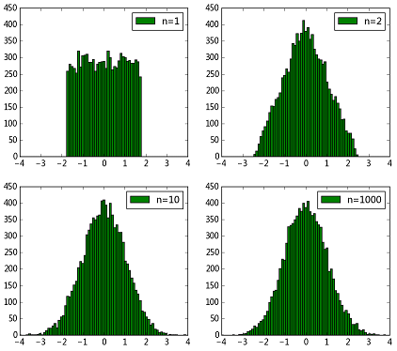

$n=1$ 时其实就是均匀分布，随着n 逐渐增大，直方图轮廓越来越接近正态分布了~ 因此利用中心极限定理暴力生成服从正态分布的随机数是可行的。但是这样生成正态分布速度是非常慢的，因为要生成若干个同分布随机变量，然后求和、计算，效率是非常低的。

## 如何学习数据分布？

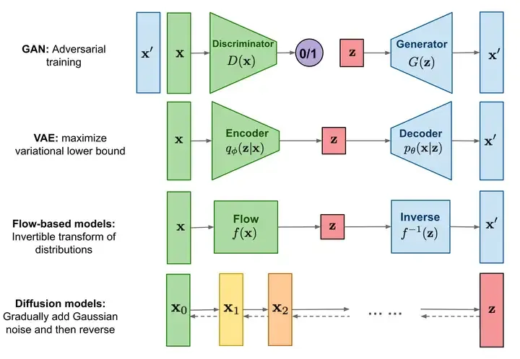

**GAN**的原理是通过判别器和生成器的互相博弈来让生成器生成足以以假乱真的图像.

**VAE**的原理是通过一个编码器将输入图像编码成特征向量，它用来学习高斯分布的均值和方差，而解码器则可以将特征向量转化为生成图像，它侧重于学习生成能力.

**流模型**是从一个简单的分布开始，通过一系列可逆的转换函数将分布转化成目标分布；

**扩散模型**先通过正向过程将噪声逐渐加入到数据中，然后通过反向过程预测每一步加入的噪声，通过将噪声去掉的方式逐渐还原得到无噪声的图像，扩散模型本质上是一个马尔可夫架构，只是其中训练过程用到了深度学习的BP，但它更属于数学层面的创新。

当你向一滴水中滴入一滴颜料时，无论你滴在什么位置，只要时间足够长，最终颜料都会均匀的分布在水溶液中

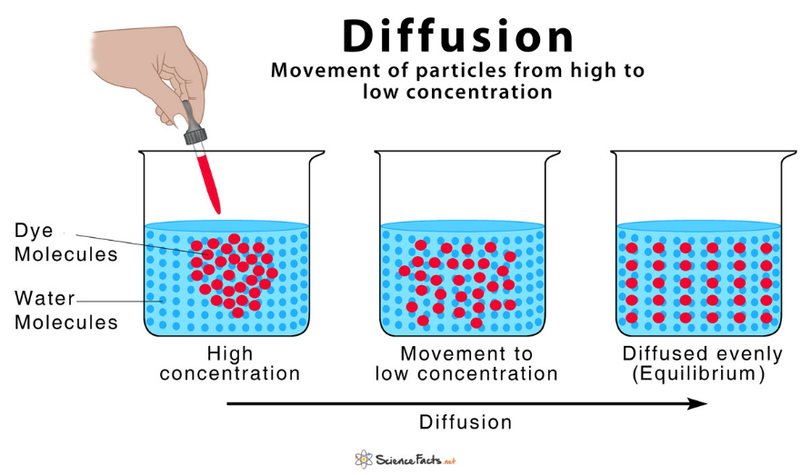

如果我们能够在扩散的过程颜料分子的位置、移动速度、方向等移动属性。那么也可以根据正向过程的保存的移动属性从一杯被溶解了颜料的水中反推颜料的滴入位置。这边是扩散模型的反向过程。记录移动属性的快照便是我们要训练的模型。

Complex data < ======== > identity-covariance Gaussian

[2020] Denosing Diffusion Probabilistic Models

[2015] Deep Unsupervised Learning using Nonequilibrium Thermodynamics

Our goal is to define a forward (or inference) diffusion process which converts any complex data distribution into a simple, tractable, distribution, and then learn a finite-time reversal of this diffusion process which defines our generative model distribution.

forward (or inference) diffusion process: 加噪过程

complex data distribution -> a simple and tractable distribution

means: slowly destroy structure in a data distribution

reverse diffusion process: 去噪过程，图片生成过程，Sampling

means: restores structure in data

via tractable generative model of the data.

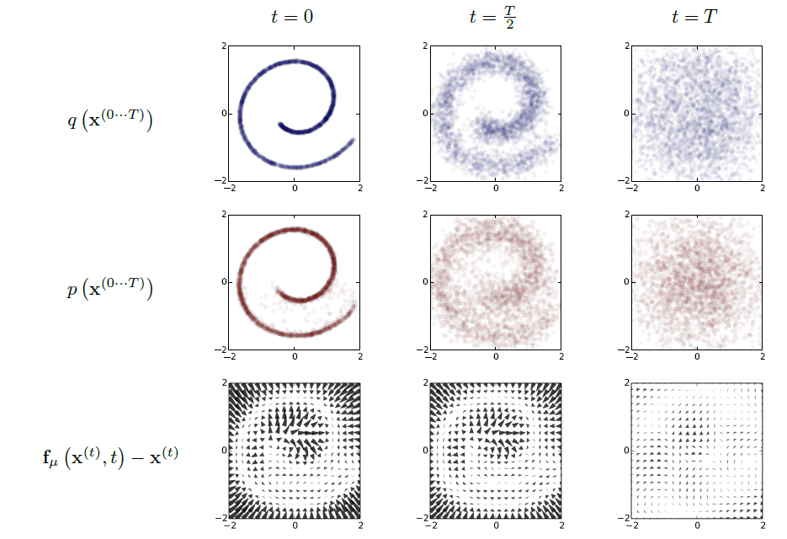 

Fig. Forward trajectory $q(x^{\left(0…T\right)})$ from data to identity-covariance Gaussian. The right is trained reverse trajectory $p(x^{\left(0…T\right)})$ from identity-covariance Gaussian with learned mean and covariance function to data.



Fig. transformation process.

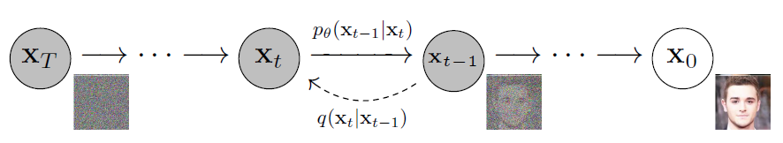

The forward trajectory based on Markov diffusion:

$q\left(x^{\left(0…T\right)}\right)=q\left(x^{\left(0\right)}\right)\prod_{t=1}^{T}{q\left(x^{\left(t\right)}|x^{\left(t-1\right)}\right)}$

While $q(x^{\left(0\right)})$ is the data distribution, $q\left(x^{\left(t\right)}|x^{\left(t-1\right)}\right)=N(x^{\left(t\right)};\sqrt{1-β_{t}}x^{\left(t-1\right)}, β_{t}I)$

The reverse Trajectory:

$p\left(x^{\left(0…T\right)}\right)=p\left(x^{\left(T\right)}\right)\prod_{t=1}^{T}{p\left(x^{\left(t-1\right)}|x^{\left(t\right)}\right)}$

While $p\left(x^{\left(T\right)}\right)$ is a simple and tractable distribution: $N(x^{\left(T\right)};0, I)$

$$p\left(x^{\left(t-1\right)}|x^{\left(t\right)}\right)=N(x^{\left(t-1\right)};μ_{θ}\left(x^{\left(t\right)},t\right), ∑_{θ}\left(x^{\left(t\right)},t\right) )$$

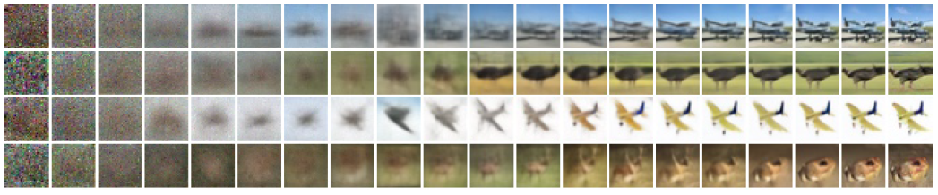

Large scale image features appear first and details appear last. When t is small, all but fine details are preserved, and when t is large, only large scale features are preserved.

[2021] Diffusion Models Beat GANs on Image Synthesis

Diffusion models sample from a distribution starts with noise $x_{T}$ and produces gradually less-noisy samples $x_{T-1}, x_{T-2}, …$ until reaching a final sample $x_{0}$. Each timestep $t$ corresponds to a certain noise level, and $x_{T}$ can be thought of as a mixture of a signal $x_{0}$ with some noise $ϵ$ where the signal to noise ratio is determined by the timestep $t$.

A diffusion model learns to produce a slightly more “denoised” $x_{t-1}$ from $x_{t}$.

[2022] High Resolution Image Synthesis with Latent Diffusion Models

**Pixel-based diffusion Models -> Latent Diffusion Models**

Evaluating and optimizing models in pixel space has the downside of low inference speed and very high training costs.

Because pixel-based representations of images contain barely perceptible, high-frequency details, maximum-likelihood training spends a disproportionate amount of capacity on modeling them, resulting in long training times. 由于基于像素的图像表示包含几乎不可察觉的高频细节，最大似然训练在对它们进行建模时会花费不成比例的容量，从而导致训练时间过长。

The analysis of already trained diffusion models in pixel space: Learning can be roughly divided into two stages: First is a perceptual compression stage which removes high-frequency details but still learns little semantic variation. In the second stage, the actual generative model learns the semantic and conceptual composition of the data (semantic compression).

通过VAE自编码模型对图片(3, 512, 512) 感知压缩(Perceptual Image Compression)，忽略掉图片中的高频信息，在潜在表示空间(4, 64, 64)迭代去噪。

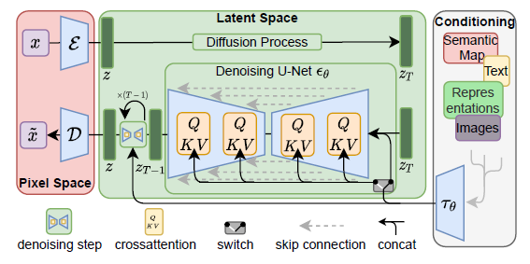

* 在潜在表示空间（latent space）上进行diffusion过程的方法，从而能够大大减少计算复杂度，同时也能达到十分不错的图片生成效果。
* **通过cross-attention实现多模态训练**，从而引入条件图片生成任务( class-condition, txt2img, layout2image, img2img, …)

SD is a two-stage diffusion model, which contains an autoencoder and an UNet denoiser. In the first

stage, SD trained an autoencoder, which can convert images X0 into latent space and then reconstruct them. In the second stage, SD trained a modified UNet denoiser to directly perform denoising in the latent space.

SD utilized the pre-trained CLIP text encoder to embed text inputs to a sequence of token

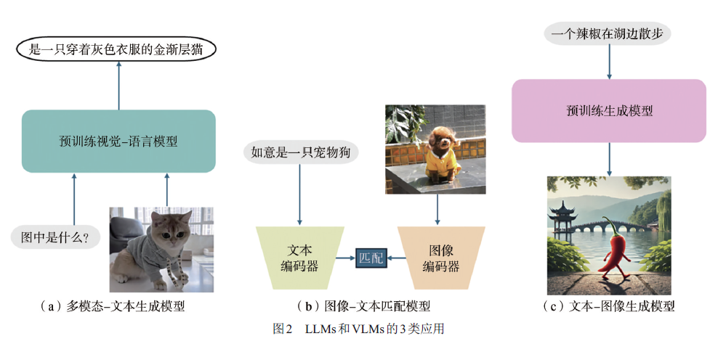

多模型-文本生成模型

# 生成图像

## Stable Diffusion

<https://jalammar.github.io/illustrated-stable-diffusion/>

<https://poloclub.github.io/diffusion-explainer/>

Stable Diffusion is a latent text-to-image diffusion model.

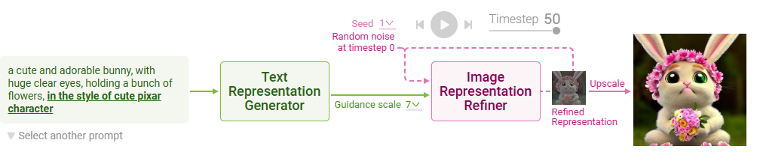

Stable Diffusion first changes the text prompt into a text representation, numerical values that summarize the prompt. The text representation is used to generate an image representation, which summarizes an image depicted in the text prompt.

Two main steps:

1. Text Representation Generation: Stable Diffusion converts a text prompt into a text vector representation.

**Tokening**

Stable Diffusion tokenizes a text prompt into a sequence of tokens. For easier computation, Stable Diffusion keeps the token sequences of any text prompts to have the same length of 77 by padding or truncating. If the input prompt has fewer than 77 tokens, <end> tokens are added to the end of the sequence until it reaches 77 tokens. If the input prompt has more than 77 tokens, the first 77 tokens are retained and the rest are truncated.

**Text encoding**

To use the text representation for guiding image generation, Stable Diffusion ensures that the text representation contains the information related to the image depicted in the prompt.

CLIP, which consists of an image encoder and a text encoder, is trained to encode an image and its text description into vectors that are similar to each other.

ClipText for text encoding (Transformer language model)

Input: text.

Output: tensor (77, 768) while 77 token embeddings vectors, each in 768 dimensions.

How to train?

CLIP is trained on a dataset (400 million) of images and their captions.

The score is to compare the image and text embedding using cosine similarity

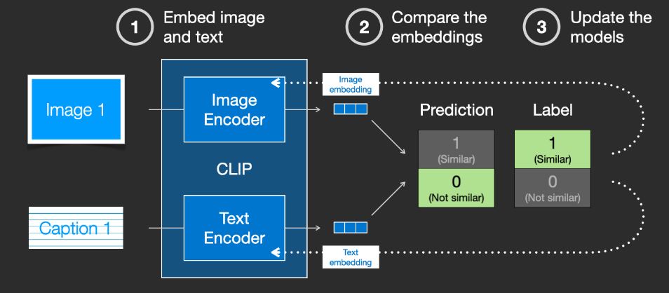

By repeating this across the dataset and with large batch sizes, we end up with the encoders being able to produce embeddings where an image of a dog and the sentence “a picture of a dog” are similar. Just like in word2vec, the training process also needs to include negative examples of images and captions that don’t match, and the model needs to assign them low similarity scores.

1. Image Representation Refining: Starting with random noise, Stable Diffusion refines the image representation little by little, with the guidance of the text representation. Stable Diffusion repeats the refining over multiple timesteps (50 in our Diffusion Explainer).

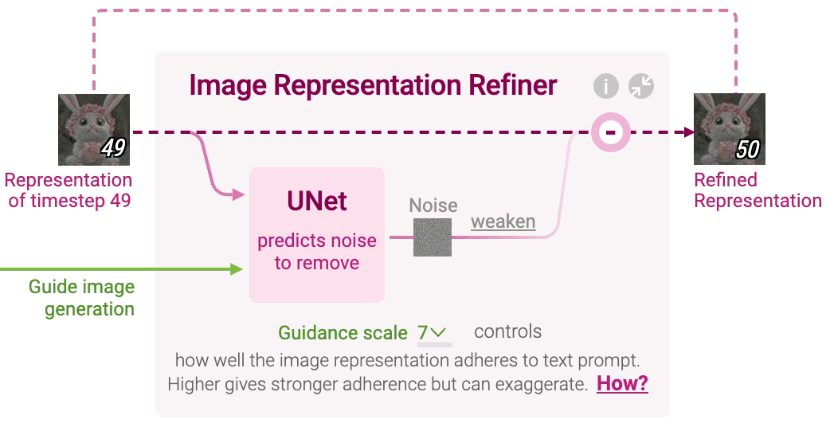

**Noise Prediction: UNet**

Input:

1. Image representation of the current timestep.
2. Text representation of the prompt to guide what noise should be removed from the current image representation to generate an image adhering to the text prompt
3. Timestep to indicate the amount of noise remaining in the current image representation

Output: prompt-conditioned noise

UNet predicts a prompt-conditioned noise in the current image representation under the guidance of the text prompt's representation and timestep.

To speed up the image generation process, the Stable Diffusion paper runs the diffusion process not on the pixel images themselves, but on a compressed latent of the image. Autoencoder Decoder will decode the final image (3, 512, 512) from latent image (4, 64, 64)

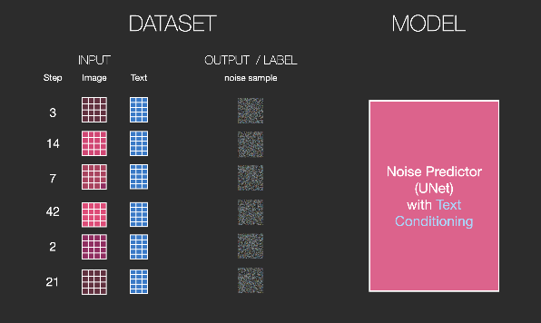 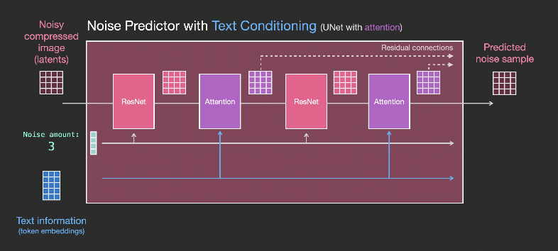

To measure the impact of the prompt,

impact of prompt = prompt-conditioned noise - generic noise

generic noise + guidance scale × impact of prompt

generic noise conditioned on an empty prompt (" "), the generic noise contributes to better image quality, while the impact of the prompt contributes to the adherence to the prompt.

A guidance scale of 0 means no adherence to the text prompt, while a guidance scale of 1 means using the original prompt-conditioned noise. Larger guidance scales result in stronger adherence to the text prompt

**Noise Removal: Scheduler**

Stable Diffusion then decides how much of the predicted noise to actually remove from the image, as determined by an algorithm called scheduler. Removing small amounts of noise helps refine the image gradually and produce sharper images.

image representation of timestep t+1 = image representation of timestep t - predicted noise

How does Stable Diffusion work?

<https://stable-diffusion-art.com/how-stable-diffusion-work/>

Stable Diffusion is generative model, which is designed to generate new data similar to what they have seen in training.

**Forward diffusion**

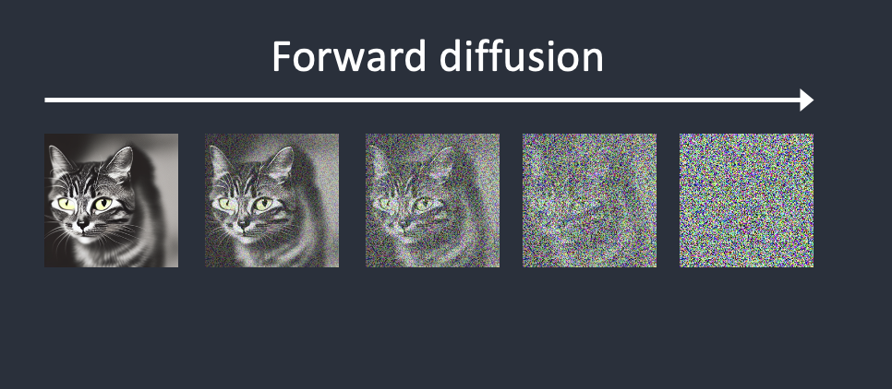

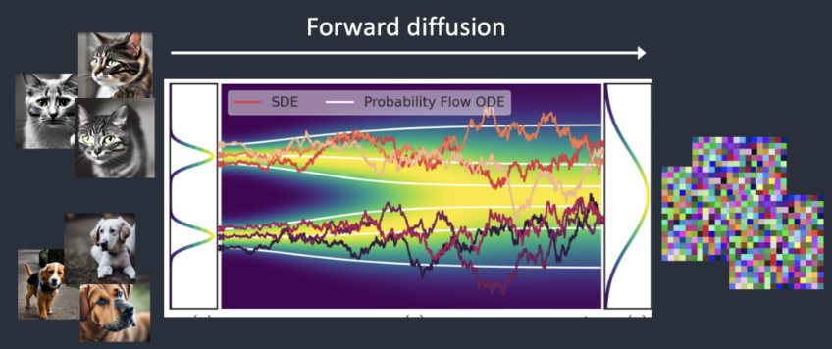

A forward diffusion process adds noise to a training image, gradually turning it into an uncharacteristic noise image. The forward process will turn any cat or dog image into a noise image. Eventually, you won’t be able to tell whether they are initially a dog or a cat.

It’s like a drop of ink falls into a glass of water. The ink drop diffuses in water. After a few minutes, It randomly distributes itself throughout the water. You can no longer tell whether it initially fell at the center or near the rim.

**Reverse diffusion**

Starting from a noisy, meaningless image, reverse diffusion recovers a cat OR a dog image.

To reverse the diffusion, we need to know how much noise is added to an image. The answer is to teach a neural network model (called noise predictor by U-Net model) to predict the noise added.

After training, we have a noise predictor capable of estimating the noise added to an image.

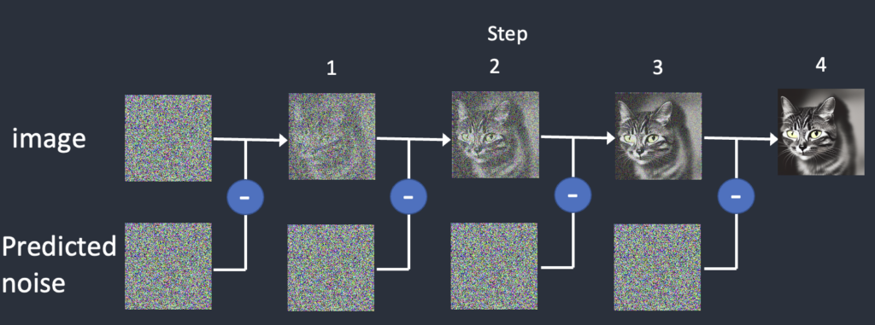

Fig. Reverse diffusion works by subtracting the predicted noise from the image successively.

We first generate a completely random image and ask the noise predictor to tell us the noise. We then subtract this estimated noise from the original image. Repeat this process a few times. You will get an image of either a cat or a dog.

**Pixel-based diffusion Models -> Latent Diffusion Models**

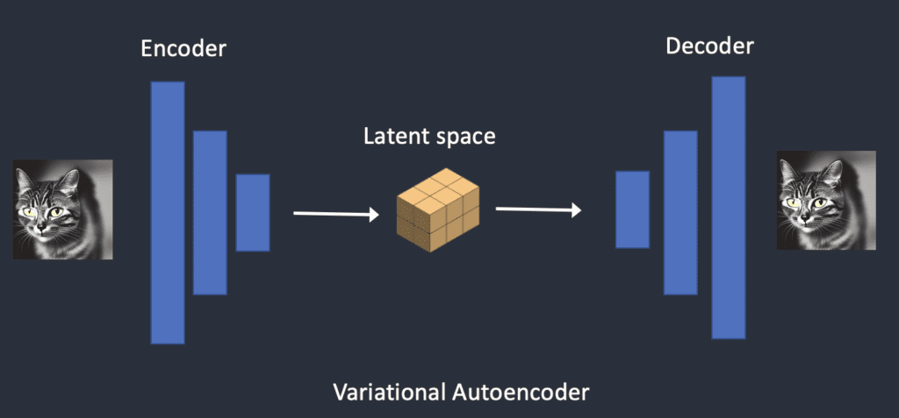

Why is latent space possible?

You may wonder why the VAE can compress an image into a much smaller latent space without losing information. The reason is that natural images are not random. They have high regularity: A face follows a specific spatial relationship between the eyes, nose, cheek, and mouth. A dog has 4 legs and is in a particular shape.

In other words, the high dimensionality of images is artifactual. Natural images can be readily compressed into the much smaller latent space without losing any information. This is called the manifold hypothesis in machine learning.

**Conditioning**

**Text conditioning (text-to-image)**

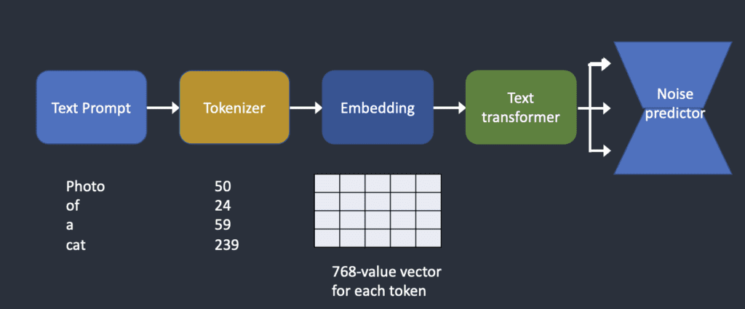

Embedding is fixed by the CLIP model

The transformer is like a universal adapter for conditioning different modalities including text, class labels, and images.

Cross-attention between the prompt and the image

Hypernetwork: fine-tune Stable Diffusion models by hijacking the cross-attention network to insert styles.

LoRA models: modify the weights of the cross-attention module to change styles.

For txt2img, a random tensor in the latent space (controlled by seed) is generated as start point

For img2img, the input image is encoded to latent space via VAE encode, then noise is added to the latent image, Denoising strength controls how much noise is added.

**Text and image conditioning**

Both a text prompt and edge image, or human pose, … are used to condition by ControlNet.

Both a text prompt and a depth image are used to condition the depth-to-image model.

CFG: Classifier-Free Guidance

Classifier guidance is a way to incorporate image labels in diffusion models. You can use a label to guide the diffusion process. For example, the label “cat” steers the reverse diffusion process to generate photos of cats.

The classifier guidance scale is a parameter for controlling how closely the diffusion process should follow the label.

In practice, this scale value is simply the multiplier to drift term toward the data with that label.

Classifier-free guidance is “classifier guidance without a classifier”, which use class labels as image captions and train a conditional diffusion model.

The classifier-free guidance scale (CFG scale) is a value that controls how much the text prompt steers the diffusion process. The AI image generation is unconditioned (i.e. the prompt is ignored) when the CFG scale is set to 0. A higher CFG scale steers the diffusion towards the prompt.

## **Conditioning: T2I-Adapter, ControlNet**

T2I models have implicitly learned capabilities, e.g., the colorization and structuring capabilities,

Various guidance such as color, depth, sketch, semantic segmentation, and key pose can be used.

**T2I-Adapter** is to learn a mapping from control information to the internal knowledge in T2I models. In a word, to learn an alignment between the condition information and internal knowledge in pre-trained models.

T2I-Adapter is a lightweight model and can be used to learn this alignment with a relatively small amount of data.

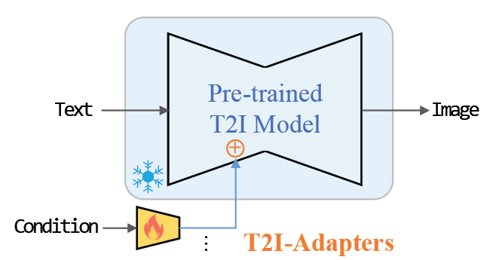

T2I-Adapter can provide extra guidance to pre-trained text-to-image models, with properties:

* Plug-and-play.Not affect original network topology and generation ability
* Simple and small. ~77M parameters and ~300M storage
* Flexible. Various adapters for different control conditions
* Composable. Several adapters to achieve multi-condition control
* Generalizable. Can be directly used on customed models

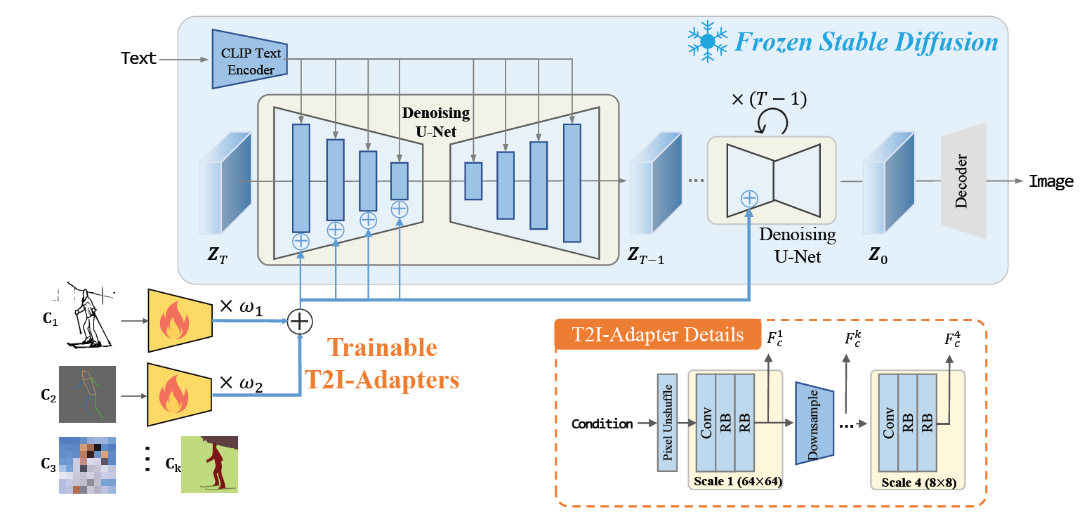

Figure. The overall architecture is composed of two parts: 1) a pre-trained stable diffusion model with fixed parameters; 2) several T2IAdapters trained to align internal knowledge in T2I models and external control signals. Different adapters can be composed by directly adding with adjustable weight !.

The main content of the generation results is determined in the early sampling stage. Therefore, the guidance information will be ignored during training if it is sampled from the later section. To strengthen the training of adapters, non-uniform sampling is adopted to increase the probability of

falling in the early sampling stage.

## ControlNet

How to finetune Neural Networks?

One way to finetune a neural network is to directly continue training it with the additional training data. But this approach can lead to overfitting, mode collapse, and catastrophic forgetting.

HyperNetwork: train a small recurrent neural network to influence the weights of a larger one

Adapter: In computer vision, adapters are used for incremental learning and domain adaptation

Low-Rank Adaptation (LoRA): prevents catastrophic forgetting by learning the offset of parameters with low rank matrices, based on the observation that many over parameterized models reside in a low intrinsic dimension subspace.

This architecture treats the large pretrained model as a strong backbone for learning diverse conditional controls.

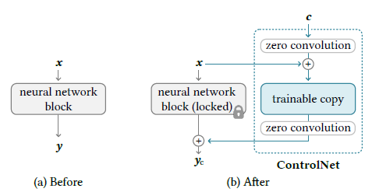

Figure. A neural block takes a feature map x as input and outputs another feature map y, as shown in (a). To add ControlNet to such a block we lock the original block and create a trainable copy and connect them together using zero convolution layers, i.e., 1x1 convolution with both weight and bias initialized to zero. Here C is a conditioning vector that we wish to add to the network, as shown in (b).

Image diffusion models learn to progressively denoise images and generate samples from the training domain. The denoising process can occur in pixel space or in a latent space encoded from training data.

During the training process, since zero convolutions do not add noise to the network, the model should always be able to predict high-quality images. We observe that the model does not gradually learn the control conditions but abruptly succeeds in following the input conditioning image; usually in less than 10K optimization steps.

P-tuned 迁移学习大模型

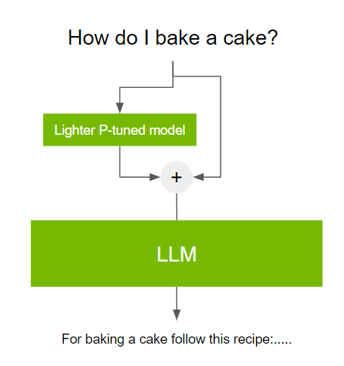

# Text Generation Models

**LLM**

In many cases, the effect of scale on performance can often be methodologically predicted via scaling laws.

LLM has emergent ability. Emergence is when quantitative changes in a system result in qualitative changes in behavior.

Emergence cannot be predicted by simply extrapolating performance on smaller-scale models.

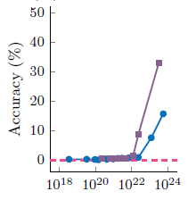 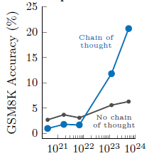

Fig. the number of model parameters in x axis.

a) The ability to perform a task via few-shot prompting is emergent when a language model achieves random performance until a certain scale, after which performance significantly increases to well-above random.

b) Specialized prompting or finetuning methods can be emergent in that they do not have a positive

effect until a certain model scale.

Multi-step reasoning. Reasoning tasks, especially those involving multiple steps, requires Chain-of-thought prompt.

Potential explanations of emergence

More parameters and more training enable better memorization that could be helpful for tasks requiring world knowledge. As an example, good performance on closed-book question-answering may require a model with enough parameters to capture the compressed knowledge base itself (though language model-based compressors can have higher compression ratios than conventional compressors.

Emergent risks

bias can increase with scaling for ambiguous contexts

大模型存在以下问题：首先，不良内容的问题尚未得到充分解决，尽管训练数据量显著增加，但其中的偏见、有害内容和隐私问题仍然存在，未对齐的大模型可能生成带有性别、社会、文化和种族偏见的内容，甚至会涉及隐私泄露；其次，大模型还倾向于生成不真实甚至虚构的内容，包括错误、幻觉和不一致性，这些问题不仅影响了大模型在一般领域的可信度，也限制了它们在医学和法律等专业领域的应用；

国外：ChatGPT, Claude, Gemini

国内：Kimi, 通义千问，文心一言

## Prompt Engineering

提示被用作与 LLM 交互以完成任务的一种手段。提示是用户提供的输入，可以包括说明、问题或任何其他类型的输入，具体取决于模型的预期用途。

提示：文本（要生成的图像的描述） 模型输出：生成的图像

提示：图像 模型输出：文本（图像字幕）

The best practices for prompting will change as more-powerful models are developed over time. more detailed prompts generally result in higher quality images

提示：简单的问题，复杂问题，数据或指令的形式

对应策略：

Zero-Shot Prompt零样本提示

零样本提示不提供任何示例，直接向预训练的LLMs提供任务指令或问题，使其利用在预训练过程中学到的广泛知识生成答案或执行任务。这种方法依赖于**模型在预训练过程中积累的语言知识和语义理解能力**。

Q: What is the capital of France?

A: （回答可能错误，模型可能不理解capital -> 少样本提示）

Few-Shot Prompt少样本提示

few-shot prompting, which includes a few input-output examples in the model’s context (input) as a preamble before asking the model to perform the task for an unseen inference-time example.

少样本提示利用上下文学习（in-contextlearning，ICL）帮助模型更好地理解任务要求和模

式，从而生成更准确的答案或执行更有效的任务。

Q: What is the capital of Spain?

A: Madrid

Q: What is the capital of Italy?

A: Rome

Q: What is the capital of France?

A:

Review: This movie sucks.

Sentiment: negative.

Review: I love this movie.

Sentiment:

Chain-of-thought思维链提示

相较于传统提示方法，思维链提示更能激发LLMs产生结构化和深入思考的回答，在算术、常识和符号推理基准测试中取得了显著的性能提升，

Q: A juggler can juggle 16 balls. Half of the balls are golf balls, and half of the golf balls are blue. How many blue golf balls are there?

A: There are 8 blue golf balls (回答可能错误，需要推理过程）

Q: A juggler can juggle 16 balls. Half of the balls are golf balls, and half of the golf balls are blue. How many blue golf balls are there?

Step 1: There are 4 balls.

Step 2: There are 2 golf balls

Step 3: There is 1 red golf ball.

So, there is 1 red golf ball.

A: Step 1: There are 16 balls.

Step 2: There are 8 golf balls

Step 3: There are 4 blue golf balls.

So, there are 4 blue golf balls.

提示技巧：明确问题、提供上下文、示例导向、逐步引导和限定范围。

明确问题是通过清晰、具体的问题描述，使模型准确理解任务，例如将“解释一下人工智能”改为“用简明的语言解释一下什么是人工智能，尽量控制在两到三句话以内”，这样便于模型生成简洁明了的回答。

提供上下文是为模型提供必要的背景信息，模型可根据更丰富的上下文理解和生成内容，例如将“写一封给客户的道歉信”改为“客户因产品配送延误而不满。请写一封道歉信，内容应包括对延误的解释、诚恳的道歉以及补救措施”，这样生成的道歉信会更加贴近实际需求。

示例导向是通过提供示例或模板指导模型生成类似风格或结构的输出，例如将“编一个笑话”改为“编一个关于程序员的笑话。例如：‘为什么程序员喜欢早起？因为他们需要打代码！’”，通过具体的示例引导模型生成类似风格的笑话。

逐步引导是将复杂任务分解为一系列简单的步骤，每一步都有明确的提示和预期输出，例如思维链（chain-of-thought，CoT）技术有助于模型逐步生成复杂的解决方案，例如将“解释如何做一个蛋糕”改为“请按以下步骤解释如何做一个巧克力蛋糕：（1）准备材料；（2）混合干湿材料；（3）烘烤；（4）装饰”，使得模型的解释更加清晰、易懂。

限定范围是通过明确限制模型生成内容的范围和风格控制模型的输出，例如将“写一篇关于环境保护的文章”改为“写一篇关于减少塑料使用的环境保护文章，字数控制在300 字以内”，这样生成的内容会更加具体。

自动化提示优化的主要技术包括：元提示（meta-prompting）[40]，通过设计提示来优化或生成其他提示，从而提升提示工程的整体效果。

[Prompt examples:](https://platform.openai.com/docs/examples)

**Lesson plan writer:** Generate a lesson plan for a specific topic.

Prompt

USER: Write a lesson plan for an introductory algebra class. The lesson plan should cover the distributive law, in particular how it works in simple cases involving mixes of positive and negative numbers. Come up with some examples that show common student errors.

**Pro and con discusser:** Analyze the pros and cons of a given topic.

Prompt

USER: Analyze the pros and cons of remote work vs. office work

**Meeting notes summarizer:** Summarize meeting notes including overall discussion, action items, and future topics.

Prompt

SYSTEM:

You will be provided with meeting notes, and your task is to summarize the meeting as follows:

-Overall summary of discussion

-Action items (what needs to be done and who is doing it)

-If applicable, a list of topics that need to be discussed more fully in the next meeting.

USER

Meeting Date: March 5th, 2050

Meeting Time: 2:00 PM

Location: Conference Room 3B, Intergalactic Headquarters

Attendees:

- Captain Stardust

…

Meeting called to order by Captain Stardust at 2:05 PM

1. Introductions and welcome to our newest team member, Ms. Comet
2. …

**Memo writer:** Generate a company memo based on provided points.

Prompt

USER:

Draft a company memo to be distributed to all employees. The memo should cover the following specific points without deviating from the topics mentioned and not writing any fact which is not present here:

…

**Translation**: Translate natural language text.

Prompt

SYSTEM: You will be provided with a sentence in English, and your task is to translate it into French.

USER: My name is Jane. What is yours?

**Grammar correction:** convert ungrammatical statements into standard English.

Prompt

SYSTEM: You will be provided with statements, and your task is to convert them to standard English.

USER: She no went to the market.

Sample response: She did not go to the market.

**Summarize for a 2nd grader:** Simplify text to a level appropriate for a second-grade student.

Prompt

SYSTEM: Summarize content you are provided with for a second-grade student.

USER: Jupiter is the fifth planet from the Sun and the largest in the Solar System. …

**Keywords:** Extract keywords from a block of text.

Prompt

SYSTEM: You will be provided with a block of text, and your task is to extract a list of keywords from it.

USER: Black-on-black ware is a 20th- and 21st-century pottery …

**Interview questions:** Create interview questions.

Prompt

USER: Create a list of 8 questions for an interview with a science fiction author.

**Product name generator:** Generate product names from a description and seed words.

Prompt

SYSTEM: You will be provided with a product description and seed words, and your task is to generate product names.

USER: Product description: A home milkshake maker

Seed words: fast, healthy, compact.

Sample response:

1. QuickBlend 2. FitShake 3. MiniMix 4. TurboShake 5. HealthWhiz

6. MightyMixer 7. SlimBlend 8. SpeedyShake 9. NutriBlend

**VR fitness idea generator:** Generate ideas for fitness promoting virtual reality games.

Prompt

USER: Brainstorm some ideas combining VR and fitness.

**Parse unstructured data:** Create tables from unstructured text.

Prompt

SYSTEM: You will be provided with unstructured data, and your task is to parse it into CSV format.

USER: There are many fruits that were found on the recently discovered planet Goocrux. …

Sample response

Fruit,Color,Taste

neoskizzles,purple,candy

loheckles,grayish blue,tart

pounits,bright green,savory

loopnovas,neon pink,cotton candy

glowls,pale orange,sour and bitter

**Spreadsheet creator:** Create spreadsheets of various kinds of data.

Prompt

USER: Create a two-column CSV of top science fiction movies along with the year of release.

**Emoji Translation:** Translate regular text into emoji text.

Prompt

SYSTEM: You will be provided with text, and your task is to translate it into emojis. Do not use any regular text. Do your best with emojis only.

USER: Artificial intelligence is a technology with great promise.

Sample response: 🤖🧠📈

**Function from specification:** Create a Python function from a specification.

Prompt

USER: Write a Python function that takes as input a file path to an image, loads the image into memory as a numpy array, then crops the rows and columns around the perimeter if they are darker than a threshold value. Use the mean value of rows and columns to decide if they should be marked for deletion.

**Improve code efficiency:** Provide ideas for efficiency improvements to Python code.

Prompt

SYSTEM: You will be provided with a piece of Python code, and your task is to provide ideas for efficiency improvements.

USER: …

**Explain code:** Explain a complicated piece of code.

Prompt

SYSTEM: You will be provided with a piece of code, and your task is to explain it in a concise way.

USER: class Log:

…

**Python bug fixer:** Find and fix bugs in source code.

Prompt

SYSTEM: You will be provided with a piece of Python code, and your task is to find and fix bugs in it.

USER: …

**Calculate time complexity:** Find the time complexity of a function.

Prompt

SYSTEM: You will be provided with Python code, and your task is to calculate its time complexity.

USER: def foo(n, k):

…

**Tweet classifier:** Detect sentiment in a tweet.

Prompt

SYSTEM: You will be provided with a tweet, and your task is to classify its sentiment as positive, neutral, or negative.

USER: I loved the new Batman movie!

Sample response: positive

**Airport code extractor:** Extract airport codes from text.

Prompt

SYSTEM: You will be provided with a text, and your task is to extract the airport codes from it.

USER: I want to fly from Orlando to Boston

Sample response: The airport codes for Orlando and Boston are MCO and BOS, respectively.

## AI Agent

Generative AI lets us experiment and invent faster than ever. Agentic AI is rapidly expanding what tasks AI can do.

Andrew Ng explores The Rise of AI Agent and Agentic Reasoning

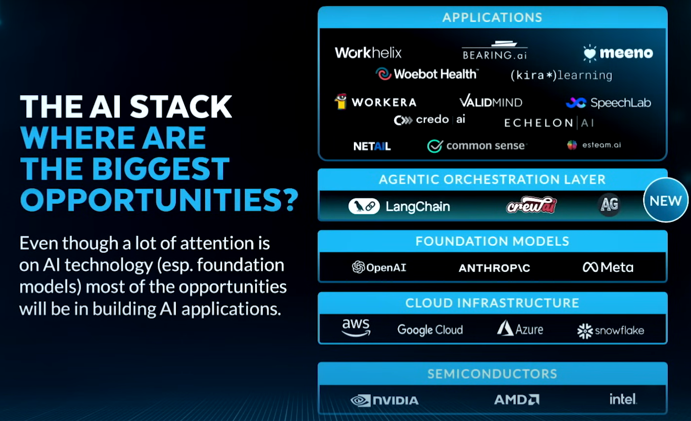

Generative AI is enabling ML product fast development

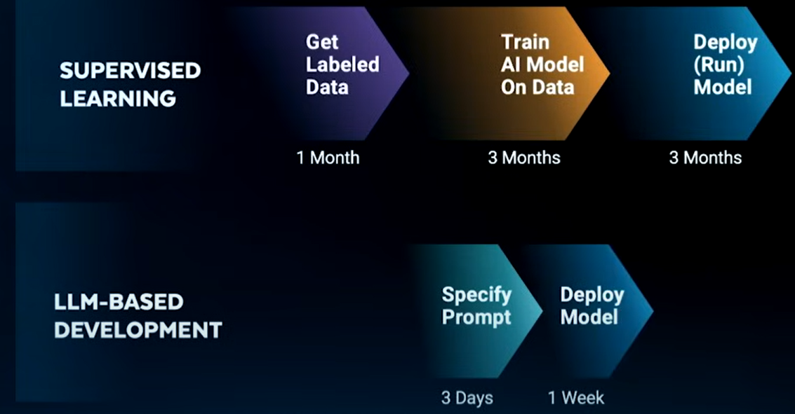

Five AI Trends

1. AI Agent
2. Agentic workflows consume a lot of tokens, and will benefit from faster, cheaper token generation. (e.g., SambaNova, Cerabras, Groq)
3. Today’s agents are build by taking LLMs trained to answer questions and retrofitting them into an iterative workflow. More LLMs will be fine-tuned for use in agentic workflows, such as to use tools, to plan/reason (e.g., OpenAI o1), or to use computers (e.g., Claude computer use). This will make agents much more capable.
4. Data engineering’s important is rising, particularly on management of unstructured data (text, images).
5. The text processing revolution has arrived. The image processing revolution is coming, and will enable many new visual AI applications in entertainment, manufacturing, self-driving, security, etc.

### AI Agent 设计模式

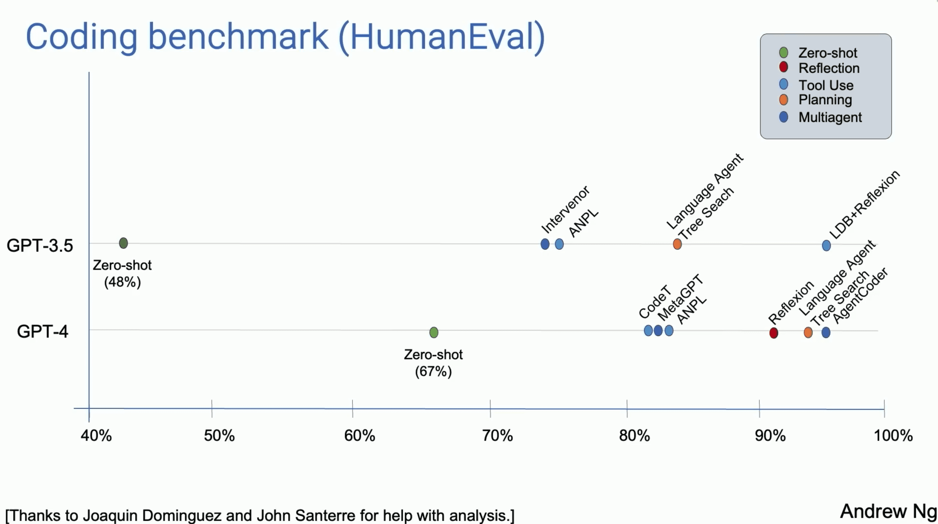

GPT 3.5的Zero-shot性能为48%, while GPT 4为67%。Zero-shot模式下，模型在没有具体任务示例的情况下，仅依赖于其预训练的知识来执行任务。

添加Agentic Workflow的AI Agent在任务执行中的表现显著提升。

Reflection反馈模式：模型通过自我反思和迭代改进。

1. 初始生成：模型根据初始任务（用户提供）生成初始解决方案。
2. 自我反馈：模型对生成的初始解决方案进行自我检查和评估
3. 迭代改进：模型根据自我反馈进行修改，生成改进版的解决方案。

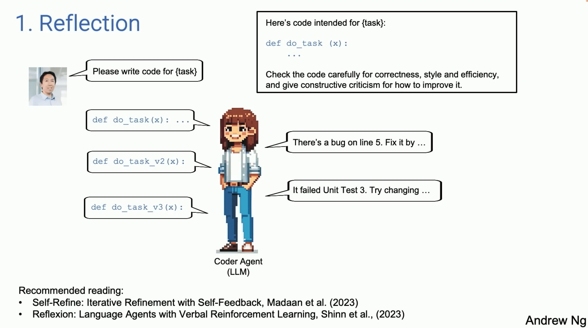

Tool Use工具调用模式：API calls

Planning规划模式：decide on steps for task

Request: Please generate an image where a girl is reading a blook, and her pose is the same as the boy in the image example.jpg, then please describe the new image with your voice.

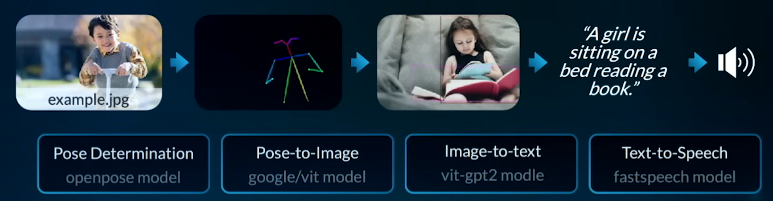

Multi-Agent Collaboration多智能体协作模式：多个智能体的协同工作

### AI Agent Frameworks

[Autogen](https://github.com/microsoft/autogen)

[Langchain](https://github.com/langchain-ai/langchain)

## OpenAI

**Text generation models (GPT-4)**

The inputs to these models are also referred to as "prompts". Designing a prompt is essentially how you "program" a model like GPT-4, usually by providing instructions or some examples of how to successfully complete a task. Models like GPT-4 can be used across a great variety of tasks including content or code generation, summarization, conversation, creative writing, and more.

**text embedding models** that take as input a text string and produce as output an embedding vector

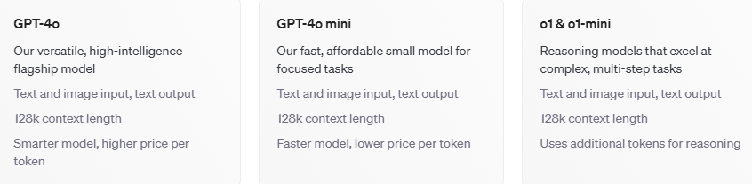

Text -> Text

While each text generation request is independent and stateless (unless you are using assistants), you can still implement multi-turn conversations by providing additional messages as parameters to your text generation request.

Image -> Text

Many OpenAI models like GPT-4have vision capabilities, meaning the models can take in images and answer questions about them

Image generation

* Creating images from scratch based on a text prompt (DALL·E 3 and DALL·E 2)
* Creating edited versions of images by having the model replace some areas of a pre-existing image, based on a new text prompt (DALL·E 2 only)
* Creating variations of an existing image (DALL·E 2 only)

Prompt: A photograph of a white Siamese cat



Inpainting: edit or extend an image by uploading an image and mask indicating which areas should be replaced. The transparent areas of the mask indicate where the image should be edited, and the prompt should describe the full new image, not just the erased area.



Fig. Image, Mask and Output. The Prompt is "A sunlit indoor lounge area with a pool containing a flamingo"

**OpenAI o1**

Models are like children: they always say the first thing that comes to mind.

As they grow and mature, they need to be taught a valuable lesson: Think before you speak.

Reasoning models:

Reasons through complex tasks in domains like mathematics, coding, science, strategy, and logistics.

Uses "chain of thought" to explore all possible paths and verify its answers.

Requires less context and prompt in order to produce comprehensive and thoughtful outputs.

OpenAI o1: reasoning model for complex tasks that require broad general knowledge.

OpenAI o1-mini: A faster, cost-efficient reasoning model tailored to coding, math and science.

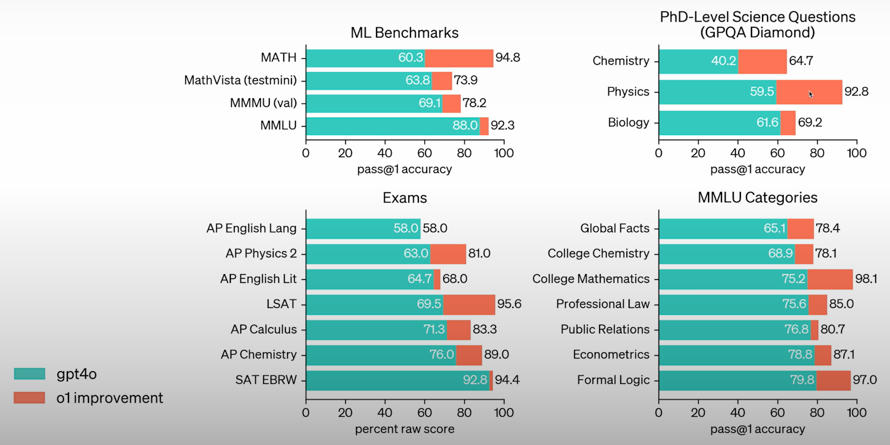

How does OpenAI o1 work?

Uses large-scale RL to generate a chain of thought (CoT) before answering

CoT is long and high-quality than what is attained via prompting

CoT contains behavior like:

* Error correction
* Trying multiple strategies
* Breaking down problems into smaller steps

Application:

Data Analysis: Interpreting complex datasets (e.g., genomic sequencing results in biology) and performing advanced statistical reasoning.

Mathematical Problem-Solving: Deriving solutions or proofs for challenging mathematical questions or in physics theory.

Experimental Design: Proposing experimental setups in chemistry to test novel reactions or interpreting complicated physics experiments’ outcomes.

Scientific Coding: Writing and debugging specialized code for computational fluid dynamics models or astrophysics simulations.

Biological and chemical Reasoning: Solving advanced biology or chemistry questions that require deep domain knowledge.

Algorithm Development: Aiding in creating or optimizing algorithms for data analysis workflows in computational neuroscience or bioinformatics.

Literature Synthesis: Reasoning across multiple research papers to form coherent conclusions in interdisciplinary fields such as systems biology.

# GAN

sample quality metrics such as FID [23], Inception Score [54] and Precision [32].

GANs are often difficult to train, collapsing without carefully selected hyperparameters and regularizers.

likelihood-based models

对抗学习

lancezhange.com/2015/11/19/adversarial-samples/

m.blog.csdn.net/liuxiao214/article/details/73485333

$ git clone <https://github.com/bstriner/keras-adversarial.git>

github.com/GKalliatakis/Delving-deep-into-GANs 资料大全

# Image Caption(看图说话)

Image Caption模型的输入是一幅图像，输出是对该幅图像进行描述的一段文字

应用：图像检索，儿童教育和视力受损人士的生活辅助等方面

encoder-decoder = CNN + LSTM



虽然在多个评价标准的得分中，最新的方法的得分已经超过人类得分，但是我仍然不认为算法的真实水平超过人类，其原因就在于这些自动评价标准（automatic evaluation metric）上

Comparing Automatic Evaluation Measures for Image Description: METEOR指标与人类判断的相关性只有0.524

For some tasks, such as Image captioning, automatic evaluation is still a difficult and open research problem

# VQA (Visual Question Answering)

Objective: Given an image and a natural language question about the image, the task is to provide an accurate natural language answer.

Dataset:

* 265,016 images (COCO and abstract scenes)
* At least 3 questions (5.4 questions on average) per image
* 10 ground truth answers per question
* 3 plausible (but likely incorrect) answers per question
* Automatic evaluation metric

four types of questions: object, count, color, location

recognition, object detection, activity recognition, knowledge base reasoning and commonsense reasoning



<https://tryolabs.com/blog/2018/03/01/introduction-to-visual-question-answering/>



Wordnet

大型的英语词典

支持自动的文本分析以及人工智能应用

名词，动词，形容词和副词各自被组织成一个同义词的网络

from nltk.corpus import wordnet as wn

wn.synsets('motorcar') #常用同义词的调用

wn.synset('car.n.01').lemma_names#获取单词指定词性、释义的同义词集

Multiple Instance Problem

某一个或者几个数据合在一起叫做一个bag，每个bag有自己的标记。当一个bag的标记为负时，这个bag里面所有样本的标记都是负的。当一个bag的标记为正时，这个bag里面至少有一个样本的标记为正。 我们的目标是学习得到一个分类器，使得对新输入的样本，可以给出它的正负标记。这样的一类问题就是多示例问题

实际应用:

比如说，方校长建长城的时候，他要列举一些违禁词汇不让大家搜索，他觉得一个一个输入太麻烦了，于是可以找来一些黄色或者反动的网站，直接作为正样本包：网站中的词汇总有一个是违禁的。然后拿健康向上的人民日报网页作为负样本包：里面的词汇没有一个是违禁的。又比如做检测问题，标记训练图片样本的时候需要给出一个矩形框指明目标的位置，有可能标的不够准确，导致不同的样本之间对不齐，这时候可以将标记的矩形框做一些局部扰动得到一些新的矩形框，将它们一起看成一个bag，其中总有一个是最佳的正样本，也就是标记为正。而取一张没有目标的图片，作为负样本包：无论在里面怎么截取图片，都是负样本。

Object Counting in video

[2017]FCN-LSTM --Deep Spatio-Temporal Neural Networks for Vehicle Counting in City Cameras

[2017] Spatiotemporal Modeling for Crowd Counting in Videos

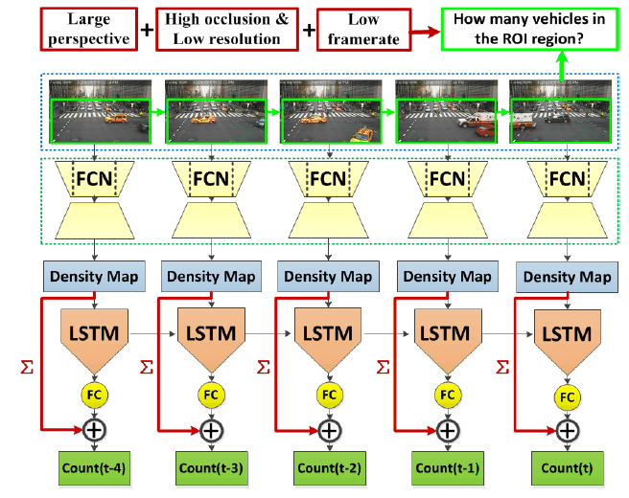 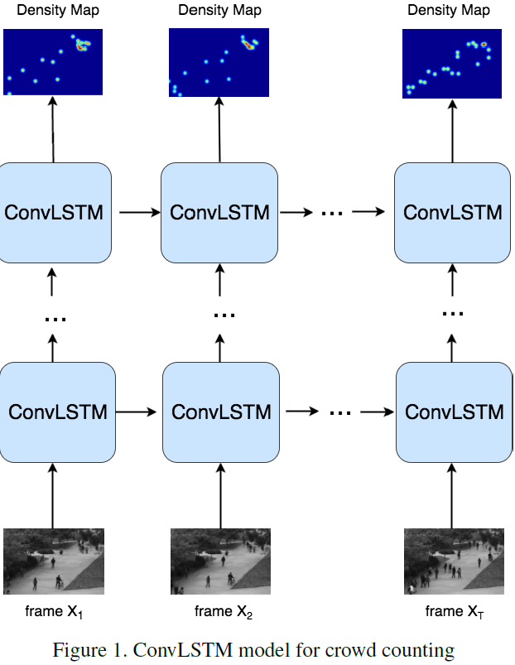

5 frames -> CNN -> density map -> reshape 2D to 1D vector -> LSTM -> count

Vehicle Counting & Crowd Counting